Table of contents

Eclipse setup 2

Eclipse PHOTON 2

Installation of Eclipse 3

Initial run of Eclipse 3

# Eclipse setup

The following sub-sections intend to describe how to get an Eclipse installation that is suitable for AviX API development.

With AviX API development, we mean developing functions “on top” of the existing AviX core framework. Examples of this may be new reports, customizations or integrations.

## Eclipse PHOTON

Eclipse Photon is the version name of the Eclipse Platform version 4.8. It was released in June 2018.

Starting point for Photon downloads: <https://eclipse.org/downloads/eclipse-packages/>.

As you will see, there exists a number of “packages” that are simply different, common configurations of Eclipse projects that are often used together. That said, Eclipse is at its core expandable by nature, so it will not matter that much which package you start out with. One can always install the necessary projects and plugins at a later stage.

Recommendation: Pick the "Eclipse for RCP and RAP Developers" (see screenshot below). Preferably, pick the 64bit version and download it.

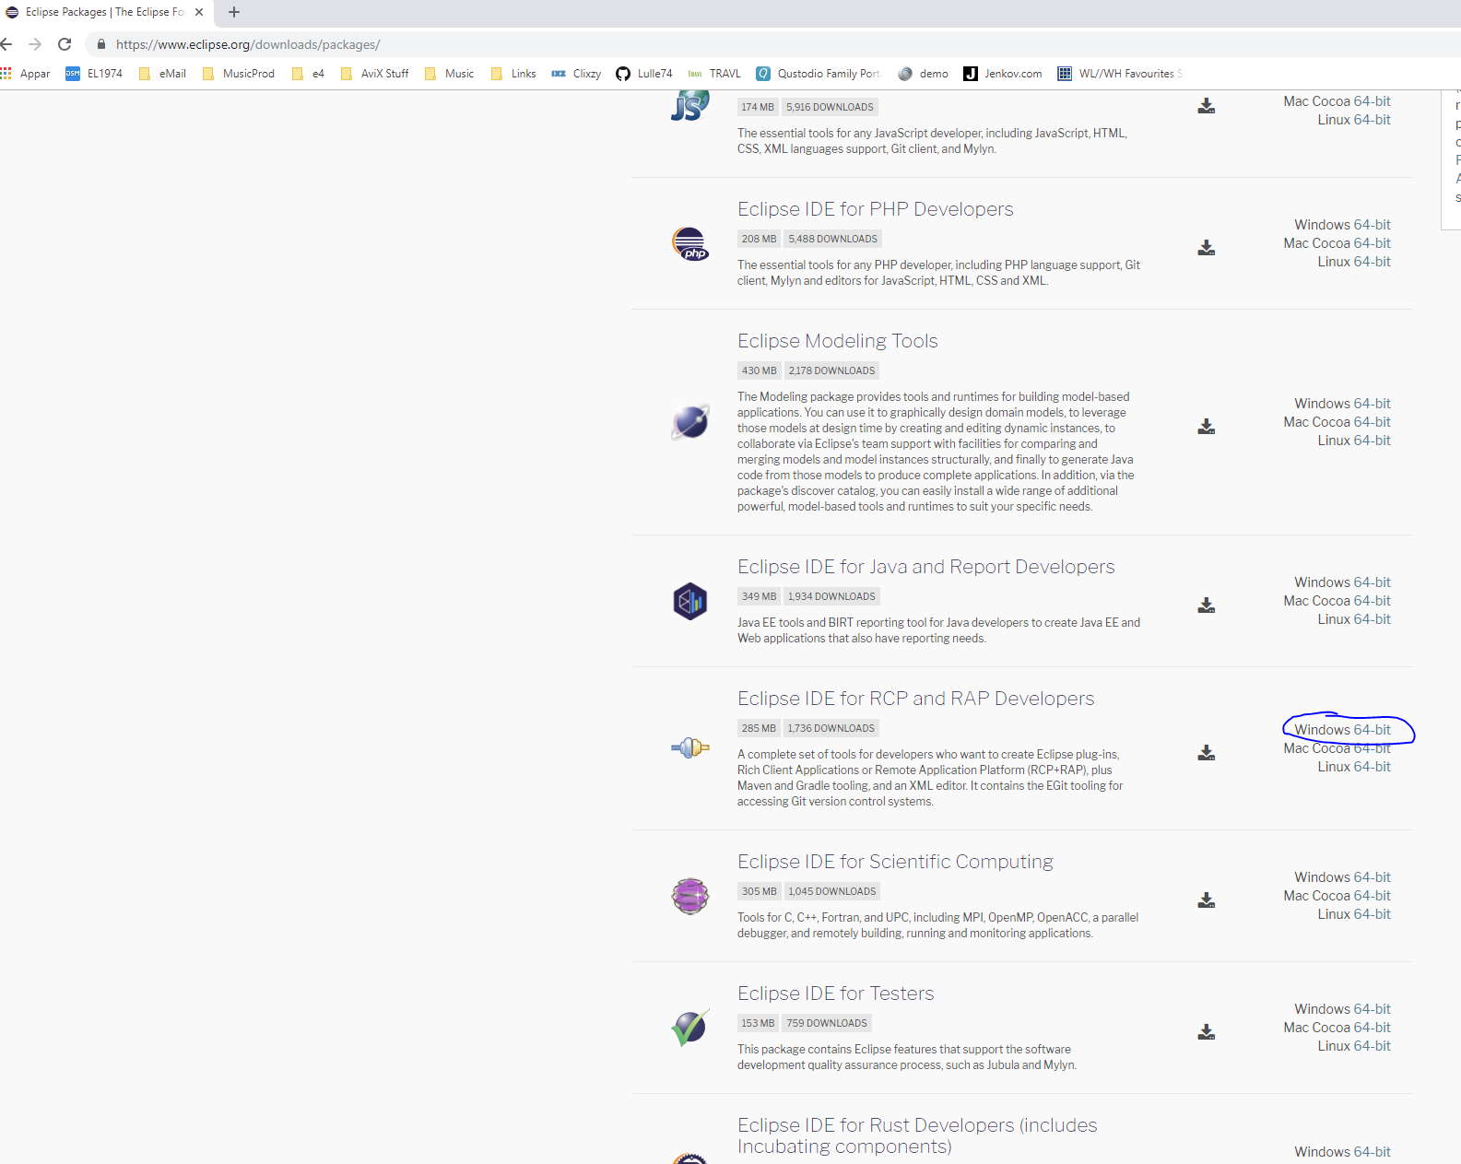

### Installation of Eclipse

Simply install by unzipping the content of the file. For example, create the following structure on your hard drive:

C:\Eclipse\Photon

And unzip the file *eclipse-rcp-2018-12-R-win32-x86_64.zip* there.

### Initial run of Eclipse

Run Eclipse (by double-clicking the executable “eclipse.exe”). It will prompt you to select a Workspace. Either you:

* (Existing Eclipse user; updating Eclipse): Select an existing Workspace directory. Eclipse may prompt you that the Workspace will be "upgraded".
* Create your Workspace directory on your hard drive, which is the place where the AviX plugins will be residing. Don’t worry – picking the default suggestion is fine for now (we are likely to change it later on anyway).

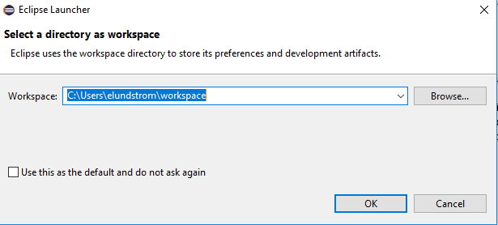

Click OK. Now Eclipse will take you to the "welcome" screen.

Now, let's start by bringing Eclipse up-to-date:

Select "Help->Check for updates". Now the update sites are contacted, and it might take quite some time. Eventually, the following screen (or similar) may be presented:

Maskingenererad alternativ text:
3 Available Updates le I Lilo I
Available Updates
Check the updates that you wish to install.
Version Id
IL21.. !I.Ee 2010021..  I
[ Select All j [ eselect All
Details
<Back Next> ] finish [ Cancel ]

If updates were found: Click "Next", accept and Finish. Upon completion, Eclipse will prompt you to restart. Upon restart, Eclipse Neon will be up to date.

***Where to head next***? Probably the “*AviX API development environment*” document. This document will detail:

* How to get the **GIT clone** of the necessary source code repository
* How to set up your “**target platform**”
* How to set up a **debug configuration**, and launch AviX in debug mode.